**Introduction**

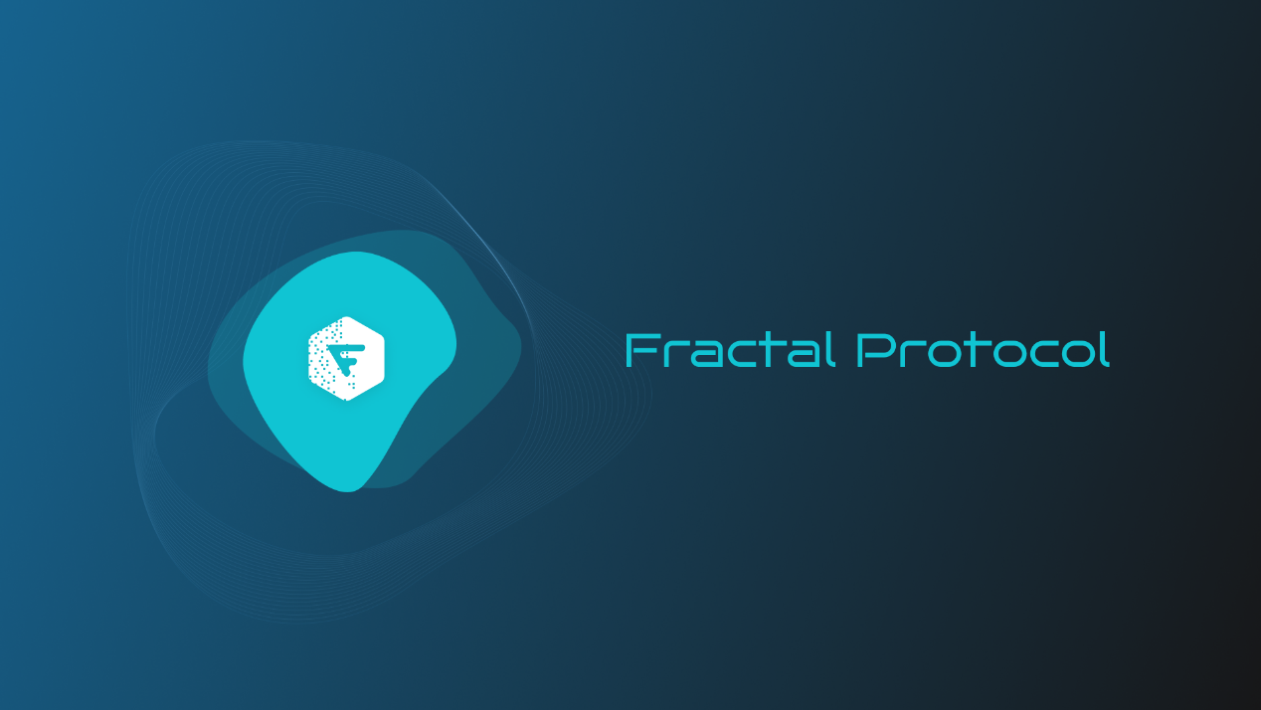

**What is Fractal?**

Fractal is building web3 infrastructure allowing all on-chain financial assets to interact with and collateralize against each other via a universal margin account – starting with existing crypto assets and expanding to real world assets.

Our goal is to make On-Chain Finance as capital efficient as CeFi.

**Value Proposition**

Fractal is an institutional-grade platform — all of our borrowers go through KYC/KYB. Fractal enables capital efficiency for institutions that are currently deployed on-chain, while also giving institutions that cannot interact with DeFi directly a way to do so by bringing bilateral agreements on-chain. In doing so, capital-efficiency is unlocked, and transparency is improved, while maintaining institutional-grade compliance.

Fractal supports institutional clients by improving:

1. 1.

Cost of capital: On-Chain Finance today is primarily fully collateralized. By creating cross-margin collateralization tooling, Fractal brings down the cost of capital and makes it far more efficient to engage in the space. The cost of capital value proposition is universal, whether it’s an early stage fintech startup, a traditional or crypto native fund, or a DAO treasury.

1. 2.

Access to credit: Fractal’s account structure and risk engine unlocks the collateral value of users’ assets in a segregated and controlled environment.

1. 3.

Transparency of risk and reserves: Fractal enables a fully transparent and programmable chain of credit, providing better credit monitoring and trust between borrowers and lenders.

**What do you support today?**

1. 1.

DeFi protocols: adapters on top of existing DeFi protocols. We currently support Aave, Compound, Curve, Convex, Uniswap, GMX, Paraswap, 1inch as well as all of their forks on all EVM chains.

1. 2.

OTC bilateral agreements: Fractal contracts tokenize bilateral agreements including options, forwards, total return and interest rate swaps. These contracts rely on off-chain price feeds between two counterparties and automatically handle margining.

1. 3.

Spot: on-chain order execution algorithms (e.g. TWAP, VWAP) with full transparency and verifiable proof of reserves.

In addition, Fractal offers 24/7 client support for all institutional clients.

# Protocol Overview

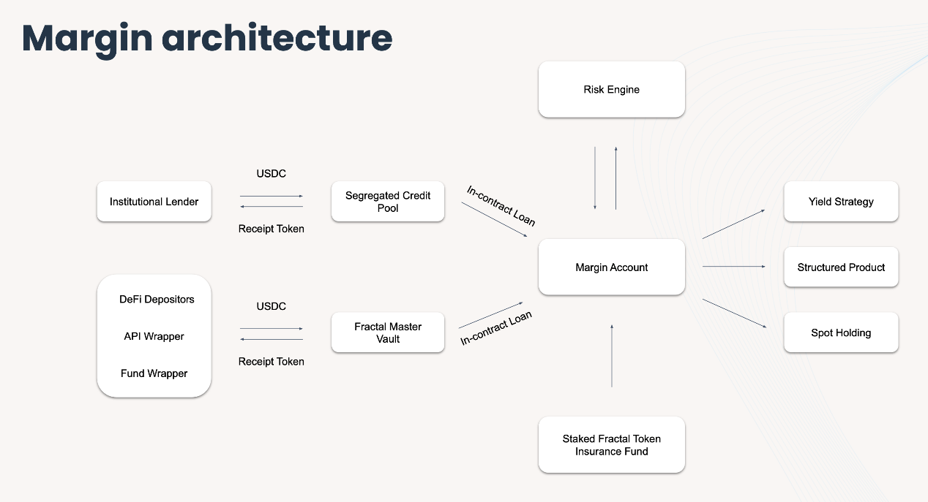

The architecture is composed of the following components:

### Credit pools

These are on chain vaults of the following types:

1. 1.

Fractal operated public pools (USDC, ETH, WBTC): permissionless and compostable DeFi pools. Our USDC pool currently has 9m TVL.

1. 2.

Integrations on top of DeFi-native lending protocols such as Clearpool, Maple or TrueFi.

1. 3.

Segregated credit pools: permissioned and lender specific on-chain credit facilities with specific risk constraints. For example, we could create a credit facility that is only underwriting delta-neutral basis strategies on ETH MainNet.

### On-chain loans

From the balance sheet source to the subaccounts

### Subaccounts

This is the core generalized contract. It is owned by the customer with select exposed functions to the risk-engine such as liquidation or the ability emergency unwind a position.

### Strategy contracts

1. 1.

Adapters on top of existing DeFi protocols. Protocols supported include Aave, Compound, Curve, Convex, Uniswap, GMX, Paraswap, 1inch as well as all of their forks on different EVM chains.

1. 2.

Structured product contracts: total return swap, interest rate swap, forwards and options. These contracts rely on an off-chain pricing feed between two counterparties and automatically handle margining.

### Risk engine

1. 1.

A software program that monitors the health of Fractal margin accounts, triggers margin calls, and liquidates customer positions should this be required. This logic is running off-chain and has the required permissions to perform the required operations on-chain. It was developed during Alex’s time at LedgerPrime running the DeFi book over 2+ years.

1. 2.

Fractal's risk framework for each asset is based on an adaptation of the [CME’s SPAN Methodology](https://www.cmegroup.com/clearing/risk-management/span-overview/span-2-methodology.html) including parameters such as volatility and price ranges, cross-asset correlation, holder distribution, and order book depth.

### Insurance Pool

The initial capital base will come from willing lenders/LPs in exchange for yield. As the network gains traction, part of the network fees will be used to fund the insurance pool until it becomes self-sustaining.

# Risk Engine

### Overview

This article shows the Fractal Protocol’s detail design of risk engine which includes several parts below:

1. 1.

Margin Sub Account

1. 2.

Health Factor

1. 3.

Liquidation Triggered Condition & Liquidation process

1. 4.

Liquidation Clearance Fees and Insurance Fund

### ****How does the margining/liquidation process works?****

* Collateral requirements & risk engine: our underwriting framework for each asset is based on an adaptation of the CME’s SPAN Methodology including parameters such as volatility, historical VaR, cross-asset correlation, token holder distribution, and DEX liquidity.
* Liquidations customer experience: Our subaccount contract design includes several waterfall liquidation states (margin_alert1, margin_alert2, margin_call, grace_period) before liquidation is triggered. These liquidations states are automated, and the client can choose what method of communication they would like those notifications to arrive through. At those intermediary stages our institutional coverage team will also make contact with the borrowers to resolve the situation. In our experience, following the past year’s events, CeFi players moved to automated liquidations on margin accounts. Our objective is to make sure that there is constant communication prior to a liquidation event.

### ****How is underwriting handled for margin lending?****

* Each sub account’s margin health is evaluated live by a Health Factor (HF) where HF = Total Account Value / Total Debt. The Total Account Value is the sum of all collateral assets contained in the sub account and a discount factor is assigned to each collateral asset based on the CME’s SPAN methodology.
* By always keeping the Health Factor healthy, combined with conservative discount factors, we can ensure that the subaccount can always be liquidated to repay the Total Debt to make the lender whole.
* As the lending pools become self-serve, lenders will be able to underwrite specific risk-tranches or strategies directly with custom parameters.

### Margin Sub Account

Margin Sub Account allows users to use DeFi and OTC positions as collateral to obtain margin loans.

The first part of the risk engine — before the user opens a position — will check each sub account’s maximum leverage, estimate the amount users can borrow, issue the loan for user and update the user’s margin status once the funds have been borrowed.

Status of sub account are shown below：

* ACTIVE
* USER_FUNDED
* MARGIN_FUNDED
* MARGIN_CALL
* LIQUIDATED
* DEFAULTED
* CLOSED
* Maximum Leverage (maximum_leverage): integer value determined on a product by product basis as well as for individuation positions. For the OTC contract, the default maximum leverage is 4x. According to maximum leverage, the risk engine estimates the maximum borrowable amount.

### Cross-counterparty margin

* Required Margin Payment: required_margin_payment = unrealized_pnl * variation_margin for both payer and receiver

### Health Factor

* The Health Factor of Sub account: health_factor = total_account_value / net_debt_amount
* Total Account Value: current total market value of all digital assets in the subaccount * collateral ratio + unrealized pnl

total_account_value = sum(balance_asset_1 * collateral_ratio_1 * price_asset_1 + ... + balance_asset_N * collateral_ratio_N * price_asset_N) + unrealized_pnl

* Discount Factor: discount applied to the value of each asset used as collateral
* Collateral Ratio: collateral_ratio = 1 - discount_factor
* Position unrealized PNL: unrealized_pnl = position_size * (underlying_mark_price - position_entry_price)
* Variation Margin (variation_margin): share of unrealized PnL that is transferred between two counter-parties to demonstrate their solvency and ability to settle.
* Net Debt Amount net_debt_amount = loan principal + interest. This is read from the smart contract directly.
* Loan principal = current total market value of all outstanding margin loans in the sub account
* Interest: interest = amount of each margin loan * loan time (in hours, by the time of the calculation) * hourly interest rate - Deduction/Paid Interest
* Total Collateral:

total_collateral = sum(balance_asset_1 * collateral_ratio_1 * price_asset_1

+ ... + balance_asset_N * collateral_ratio_N

* price_asset_N)

* Collateral Used: collateral_used = ∑(asset_variation_margin * asset_position_notional)
* Free Collateral: free_collateral = total_collateral - collateral_used
* Margin Fraction:

margin_fraction = total_account_value / sum(abs(derivative_position_notional_i))

​

where: derivative_position_notional = swap_contract_units * underlying_price

​

* Maintenance Margin Fraction:

maintenance margin fraction = sum(derivative_position_notional_i * variation_margin_i)/sum(derivative_position_notional_i)

​

where: derivative_position_notional = swap_contract_units * underlying_price

### Liquidation Triggered Condition & Liquidation process

According to maximum leverage, use 4x as example:

When HEALTH_FACTOR_TRIGGER_MARGIN_CALL_TWO(1.1) < health_factor < HEALTH_FACTOR_TRIGGER_MARGIN_CALL_ONE(1.2): A margin call one will be triggered. The system will inform you through email notification* to add more margin (transfer in more collateral assets) to avoid liquidation risk.

When HEALTH_FACTOR_TRIGGER_PARTIAL_UNWIND(1.07) < health_factor < HEALTH_FACTOR_TRIGGER_MARGIN_CALL_TWO(1.1): A margin call two will be triggered. The system will inform you through email notification* to add more margin (transfer in more collateral assets) to avoid liquidation risk.

When HEALTH_FACTOR_TRIGGER_FULL_UNWIND(1.05) < health_factor < HEALTH_FACTOR_TRIGGER_PARTIAL_UNWIND(1.07): the system will execute the partial liquidation process. The system will close all opened OTC contracts under subaccount , swap assets back to USDC based on estimated liquidation percentage and trigger loan repayment.

When health_factor < HEALTH_FACTOR_TRIGGER_FULL_UNWIND(1.03), the system will execute the full liquidation process. the system will execute the partial liquidation process. The system will close all opened OTC contracts under subaccount , swap all assets back to USDC and trigger loan repayment.

### ****Liquidation Clearance Fees and Insurance Fund****

The Margin Insurance Fund is designed to make up for losses incurred when the user’s sub account equity (asset minus liability) is less than 0, or when the user is unable to repay debts on crypto Loan.

When the user sub account is being liquidated, the Fractal margin insurance fund will charge a certain percentage in Liquidation Clearance Fees: net debt amount * 2%